**SUPPLEMENTARY MATERIALS:** Foraging, fear and behavioural plasticity – a lesson from hummingbirds

*Katarzyna Wojczulanis-Jakubas, Marcelo Araya-Salas*

**Results on single predictor models**

To examine foraging efficiency (response variable) in regard to the context, behavioural parameters and their all interactions (predictors) we applied Bayesian MCMC generalized linear modelling, with bird’s identity included as a random factor. We performed the analyses in two approaches. In the first one, we run analysis for each behavioural parameter separately (“single behaviour-predictor models”). In the second approach, all the behaviour-predictors were considered in a single, global model. The two approaches yield qualitatively similar results (Fig. S3), therefore we presented the latter in the main text, and below we present the outcome of the single behaviour-predictor models.

Three models were compared for each behavioural parameter:

1. only context as predictor (i.e. **“classical” hypothesis**):

*foraging* *efficiency*∼*context*+(1|*indiv*)

1. context, behavioural parameters and their interaction as predictors

(**alternative hypothesis accounting for individual differences**):

*foraging* *efficiency*∼*context*∗*behavioural* *parameter*+(1|*indiv*)

1. Null model with no predictor:

*foraging* *efficiency*∼1+(1|*indiv*)

**Model selection results**

**Table S1.** Ranking of models explaining foraging efficiency of long-billed hermits, ordered by delta Deviance Information Criterion (DIC; Akaike’s Information Criterion AIC yields to same conclusions). Best model for each parameters is bolded.

|  |  |  |  |  |  |  |  |  |
| --- | --- | --- | --- | --- | --- | --- | --- | --- |
| **Response** | **Predictors** | **df** | **DIC** | Δ **DIC** | **weight DIC** | **AIC** | Δ **AIC** | **weight AIC** |
| **arousal** | **Context interaction** | **6** | **-365.8347** | **0.00** | **1.00** | **-365.8307** | **0.00** | **1.00** |
| arousal | Parameter | 4 | -328.9776 | 36.86 | 0.00 | -331.0490 | 34.78 | 0.00 |
| arousal | Context | 4 | -309.6083 | 56.23 | 0.00 | -312.2369 | 53.59 | 0.00 |
| arousal | Null | 3 | -298.5859 | 67.25 | 0.00 | -302.1584 | 63.67 | 0.00 |
| **exploration** | **Context interaction** | **6** | **-348.0369** | **0.00** | **1.00** | **-348.9852** | **0.00** | **1.00** |
| exploration | Context | 4 | -310.8631 | 37.17 | 0.00 | -313.1746 | 35.81 | 0.00 |
| exploration | Parameter | 4 | -307.5661 | 40.47 | 0.00 | -310.6167 | 38.37 | 0.00 |
| exploration | Null | 3 | -298.6007 | 49.44 | 0.00 | -302.1654 | 46.82 | 0.00 |
| **risk_avoidance** | **Parameter** | **4** | **-314.1987** | **0.00** | **0.53** | **-316.4061** | **0.00** | **0.72** |
| risk_avoidance | Context interaction | 6 | -313.7740 | 0.42 | 0.43 | -314.0783 | 2.33 | 0.23 |
| risk_avoidance | Context | 4 | -308.9691 | 5.23 | 0.04 | -311.0324 | 5.37 | 0.05 |
| risk_avoidance | Null | 3 | -296.4492 | 17.75 | 0.00 | -299.8973 | 16.51 | 0.00 |

**Interpretation:** All best models contained an interaction with a behaviour parameter. All models with interaction provided a better fit than the context (low vs high risk) models; effect sizes for the models with interaction terms presented in Table S2.

**Table S2.** Effects of behavioural variables and predation context on foraging efficiency of long-billed hermits. Effects are model slope estimates derived from Bayesian MCMC generalized linear model. Only models that improved fit compared to the null models are presented.

|  |  |  |  |  |  |  |  |  |  |
| --- | --- | --- | --- | --- | --- | --- | --- | --- | --- |
| **Response** | **Parameter** | **Predictor** | **Effect size** | **CI 2.5%** | **CI 97.5%** | **pMCMC** | **intercept** | **N indv** | **N obs** |
| foraging effiency | arousal | contextHigh risk | -0.0352 | **-0.0668** | **-0.0021** | 0.0347 | 0.5343 | 12 | 193 |
| foraging effiency | arousal | arousal | 0.0663 | **0.0195** | **0.1072** | 0.0044 | 0.5343 | 12 | 193 |
| foraging effiency | arousal | contextHigh risk:arousal | 0.2815 | **0.1853** | **0.3802** | 0.0001 | 0.5343 | 12 | 193 |
| foraging effiency | exploration | contextHigh risk | -0.0645 | **-0.0972** | **-0.0316** | 0.0002 | 0.5346 | 12 | 193 |
| foraging effiency | exploration | exploration | 0.3039 | **0.034** | **0.5697** | 0.0296 | 0.5346 | 12 | 193 |
| foraging effiency | exploration | contextHigh risk:exploration | -1.1133 | **-1.4827** | **-0.7451** | 0.0001 | 0.5346 | 12 | 193 |
| foraging effiency | risk_avoidance | risk_avoidance | -0.0648 | **-0.0924** | **-0.0377** | 0.0001 | 0.5209 | 11 | 192 |

**Supplementary figures:**



**Figure S1.** Distribution of foraging efficiency and behavioural parameters in the study population of the long-billed hermits, raw (A) and log-transformed (B) data.

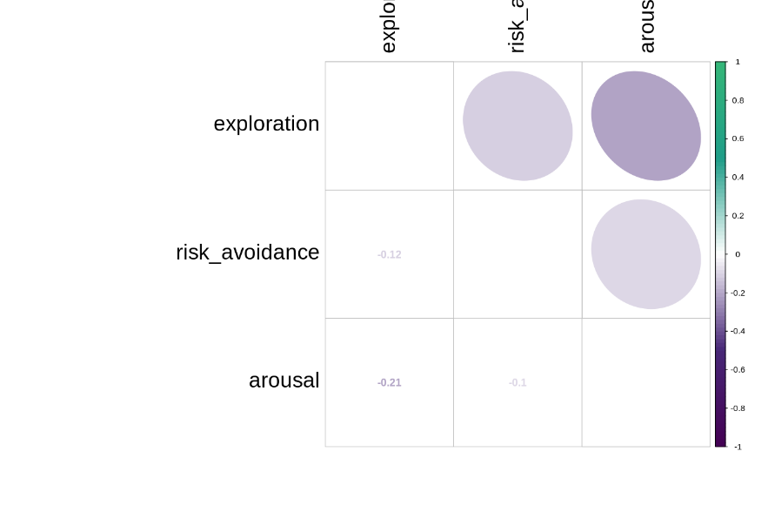

**Figure S2.** Correlation coeficents between the three behavioural variables.

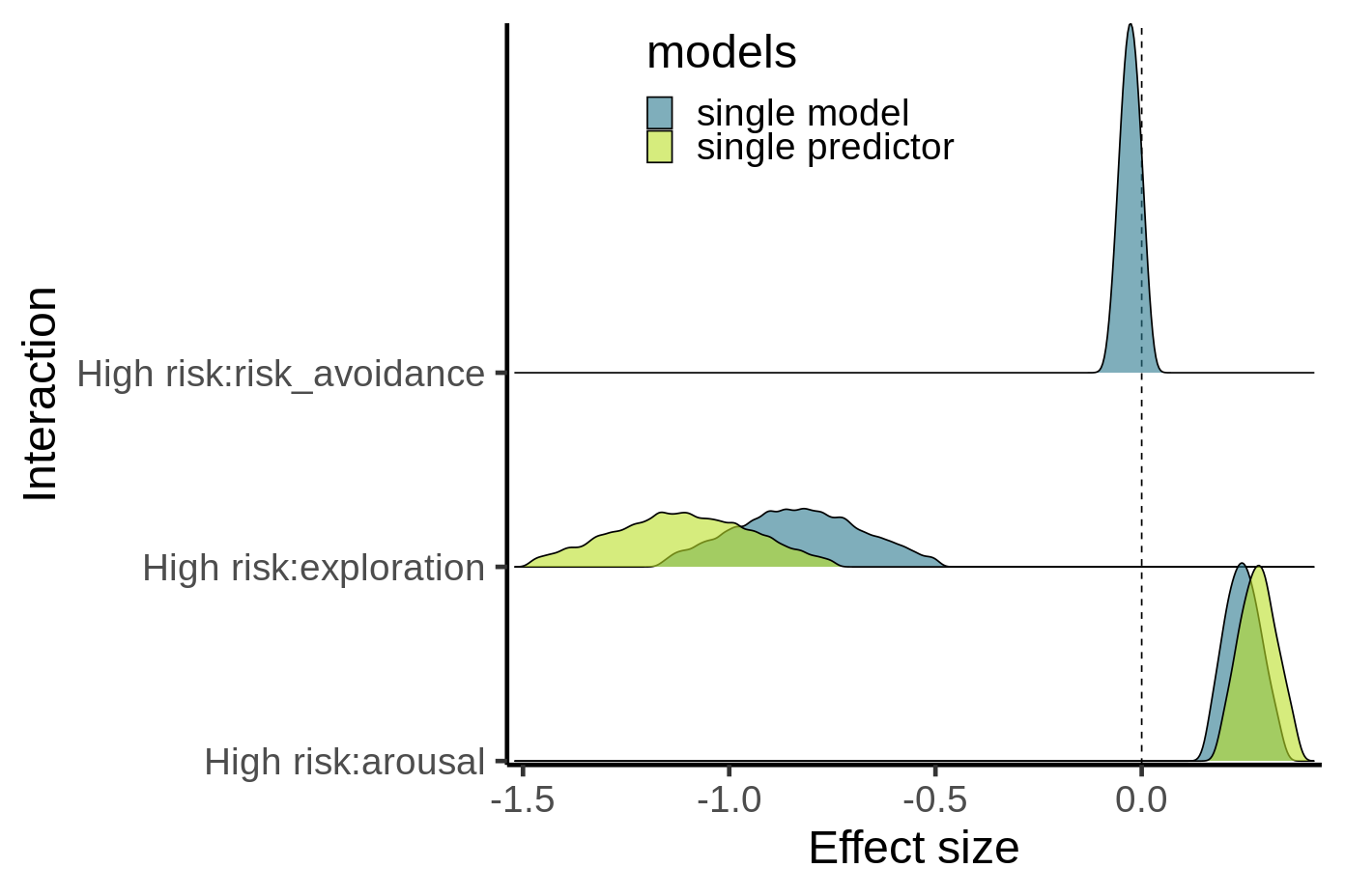

**Figure S3.** Comparison ofestimates from single predictor models and the global model.